### Functional testing types (or) Black box testing types:

#### Smoke testing:

* Once the build is developed and deployed it in any environment then the initial testing will be performed, that is known as smoke testing. Initially the development team will deploy the build in development environment, and perform smoke test. They will check each and every module related field is properly navigating their pages or not and checks the main functionality of the application. The objective of smoke test is to check whether the build is ready for further testing or not. The developer will concentrate on white box testing
* If all these fields are properly navigating to the related pages then they will conclude that smoke test is passed.

#### Sanity testing:

* Once the build is deployed in the test environment, the testing team will perform the smoke test in test environment. It is known as sanity testing.
* In sanity test the testing team will perform at least one round of the main flow functionality and check whether its properly working or not.
* If sanity test is passed then the testing team will execute all the test cases if it fails they will reject the build to the development team.

Ex for Main flow: Create an account in Gmail and login into that account and compose email and send it to one valid email and check that whether it is properly delivered or not.

**Note:**Once the sanity test is performed the testing team (test lead) has to send an email with sanity test results to the development team.

1. **Pre SRN testing:**SRN - Software Release Notes

* It contains the build status like, number of modules available in the build for testing.
* Number of modules which are under development.
* Number of stubs and drivers are available in the build.
* Number of bugs which are fixed and available in the build.
* Number of bugs which are under development
* Deployment guidelines etc..
  + Before releasing the SRN document along with the build to the testing team, the testing team will perform the smoke test in development environment, is known as Pre-SRN Testing
  + It is also known as *Build acceptance testing (BAT) or Build verification testing (BVT).*

*Note:* Once the build is released to the testing team, the test engg's will review the SRN doc to know the build status (what build contains). Then the testing will perform sanity test.

1. The order is initially the Dev team will perform Smoke testing, then the testing team will perform Pre-SRN testing in Dev Env. If both are pass then the Dev team will release the build to testing team then the testing will perform sanity testing

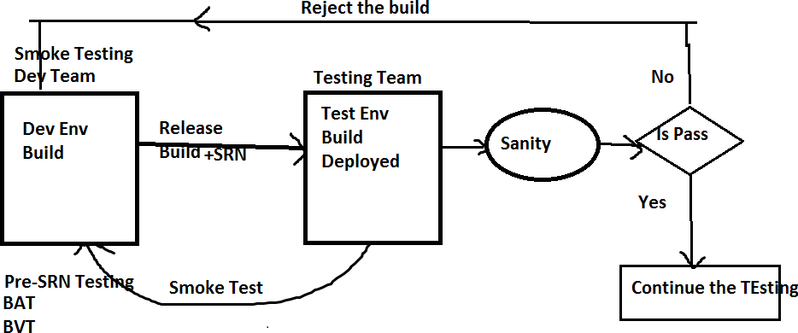

#### GUI/UI Testing:

Graphical user interface/user interface testing. The below five activities will be tested in GUI.

* + Check the spellings of all the fields.
  + Check the font of all the fields where it should maintain the consistency.
  + Check the color and alignments of all the fields it should maintain the consistency.
  + Check the overall look and feel of the page

#### Regression testing:

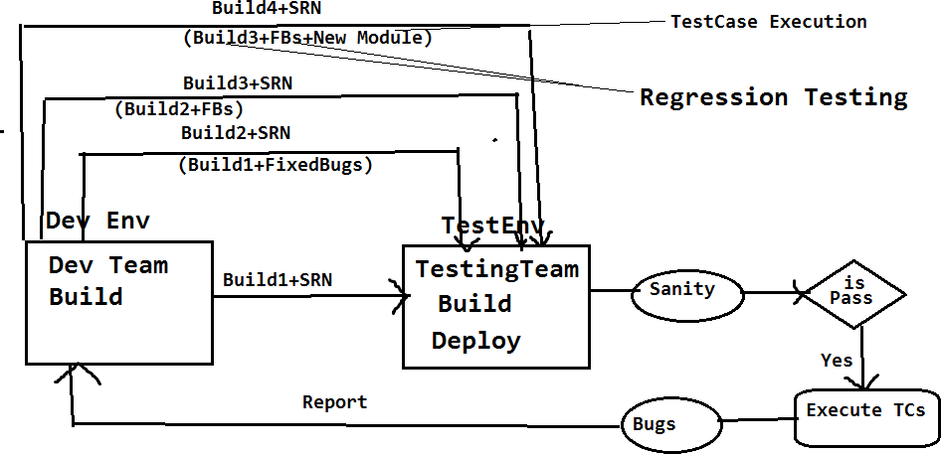

Performing testing on already tested functionalities on the iterative and incremental builds is known as ‘*Regression Testing’*.

It will be performed in two ways:

* Whenever any bug is identified it will be reported to the developer, the developer will fix it then he will releasing the fixed bug in the form of new build(Build2) to the testing team.The test engineer will test again, to check whether the bug is really fixed or not.
  + The test cases which are passed on the old build will be executed again on the new build and check that whether these are working same as previous or not.

Testing already tested functionalities is *regression testing.* Testing the new functionalities is not the regression testing. It comes under test case execution.

**Note:**If any code update is there,then that new code may affect the existing code, so we are performing the regression testing.

#### Retesting:

* + Perform testing on the same functionalities again and again with multiple sets of different test data on the same build is known as ‘*Retesting*’.
  + Executing the failed test cases on the iterative and incremental builds is also known as “Re testing”.

**Test data:**The data which the testing team is using for testing is known as “*Test data*”.

**Ex: 1.** Test the login functionality of Gmail with multiple sets of different credentials.

2. Test the spicejet one way search with the multiple sets of different origins and different passengers.

Q: What is the difference between Regression Testing and Retesting

Q: What is the difference between Regression Testing and integration Level Testing

#### End to End Testing:

The test engineer has to identify all the end user used scenarios of the application, and check that whether the End to End Scenarios are properly working or not

By performing End To End testing we can achieve Integration level testing

**Ex**: The end to end scenario for Gmail.

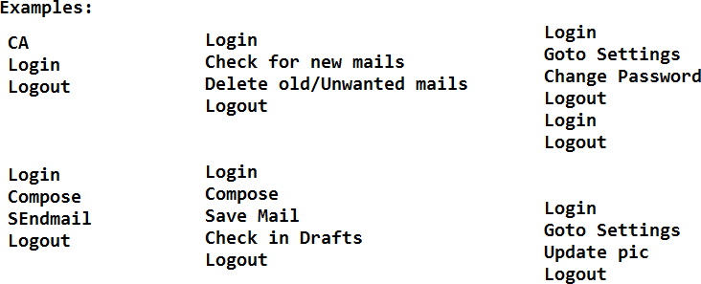

#### Compatibility Testing:

* + Test whether the application is working same as expected in all the targeted

environments or not is known as ‘*compatibility testing*’. Environment is combination of OS, Browser, Server, DB etc.

* + Compatibility testing is two types ‘*cross browser testing’* and ‘*cross platform testing’*.
  + Test whether the web application is working as expected in all the targeted browsers like firefox,safari,google chrome,IE etc. is known as ‘*cross browser testing’.*
  + Test whether the desktop application is working as expected in different platforms or operating systems like windows,LINUX,MAC,Solaris etc. is known as ‘*cross platform testing’.*

**Ex** for Cross browser testing: Test whether the spicejet is working in the below environments or not.

Windows – Internet explorer, Firefox, Google chrome, Safari, Opera Linux - Internet explorer, Firefox, Google chrome, Safari, Opera MAC - Firefox, Google chrome, Safari, Opera

**Ex** for Cross platform testing:Test whether the skype is working in the below platforms or environments

Windows Linux

MAC and Mobile

**Note:** Whenever we are performing compatibility testing we need to concentrate more on GUI of the application

#### Usability testing:

* + *Usability* means user friendliness. The test engineer has to provide usability to the application for the end user satisfaction.
  + Depends on the application we have to provide the usability.

**Ex:** For Banking (secured) application we have to provide more security whereas for social sites (Face book, twitter)**,** we need to provide more user friendliness.

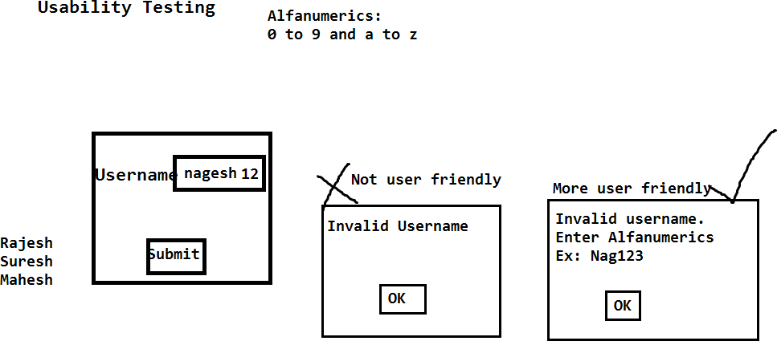

#### Adhoc Testing:

* + Adhoc means in our own way.
  + *Adhoc testing* means test theapplication in your own way, After understanding all the requirements and at least one round of manual testing is completed on the application
  + The main purpose of adhoc testing is to provide usability to the application.

#### Exploratory Testing:

* + *Exploratory* means identifying the new requirement / new Feature. Once the build is stable the domain experts will test the application as per their domain knowledge, while testing they will explore ifthe existing requirements are sufficient, if not they will provide the new requirements.
  + The main purpose of exploratory testing is to provide usability and security to the application.

#### Monkey testing/Gorilla testing:

* + Once the application is stable then we can go for monkey testing.
  + Perform testing on the application by doing some abnormal actions is known as

*Monkey/Gorilla testing*.

* + Abnormal actionsmeans continuously click on some field for long period of time and check that whether the application is crashing or not.
  + Test the application with invalid data like HTML tags (<html>) and check that whether the application is crashing or not.

**Note**: The objective of monkey testing is to check whether the application is crashing or not (Means will get server not found exception)

#### Static testing:

* + Testing the application without performing any action is known as *static testing*.

**Ex:**1. GUI testing

2. Validations:- checking the availability of the fields in the page comes under static testing.

#### Dynamic Testing:

* + Test the application by performing some action is known as *dynamic testing*.

**Ex:** Regression testing, Retesting, Adhoc testing etc…

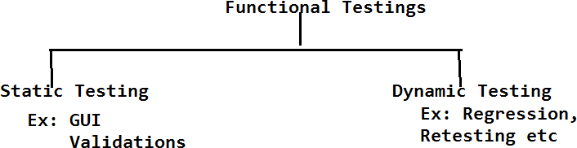

#### Authentication testing:

* + Authentication means check whether the secured credentials/data is available in the database or not.
  + *Authentication testing* means test the application with multiple sets of valid and invalid data, for valid data it should display the homepage, whereas for invalid data, it should display the proper authentication message (error message).

**Ex:** Test the login functionality of HMS with multiple sets of valid and invalid credentials. It has to authenticate the application properly.

#### Direct URL testing:

* + Login into a secure page and take the URL of the secured page and access that URL in a new browser. Where it should not be accessible if it is accessible then the application is not secured.

**Ex:** Login into Gmail.com, copy the URL of the home page. Open in new browser and access the URL directly, where it should not be accessible.

#### Firewall Leakage Testing:

* + Login into the application as one level of user and try to access the data beyond your role limitation.If it is accessible then we conclude that the application is not working as per the role (It is having the firewall leakage).

**Ex:** Login into the HMS application as Jr. Doctor and try to access the data of Sr. Doctor, where it should not be accessible

#### Database Testing:

* + Test whether the data is properly inserting into the database of all the tables or not is known as *database testing*. With the help of SQL queries we can perform DB testing.

**Ex:** Whenever we are creating the permanent registration in HMS, all the patient details will be stored in HMS database, as a test engineer we have to login into the database and check that whether the data is properly inserted in all the tables or not.

**Deployment Testing/ Installation Testing:** The deployment team or Test lead will deploy the build in multiple environments like dev, testing, stage1,stage2, production etc and check that whether its properly deploying or not

##### Q: Once the build is released, how you will test the build

**A: Initially we will perform sanity testing, if it is pass then we will execute all the test cases then will perform all the functional testing types as below.By performing all the below testing then we can ensure for quality for the application**

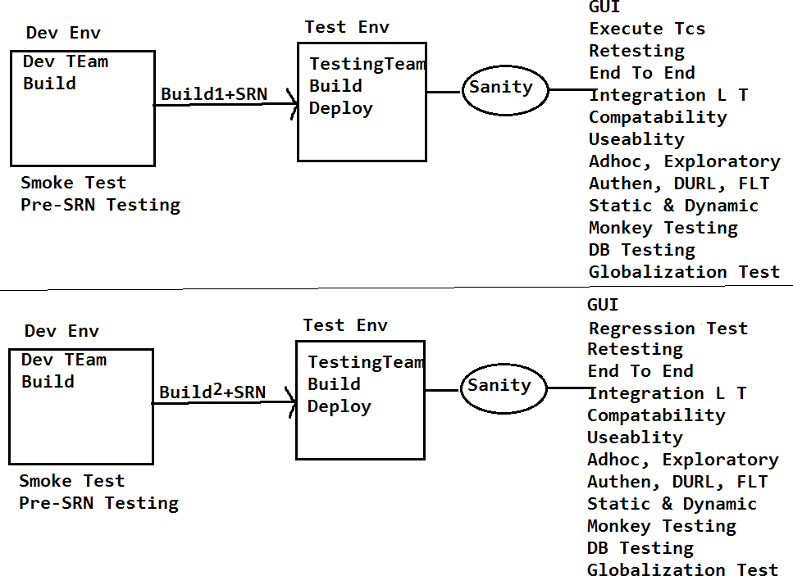

**Functional Testing types – Function testing’s execution flow on the Build, once its released to**

**testing team**

**Note:** For any application all the above testing's will be performed to ensure, whether the application is fulfilling the clients requirements, quality and its useful for enduser or not.

2. If it is a desktop top application Direct URL Testing and cross browser testing is not possible to perform.

#### Review Report Template:

Review the SRS document of spice jet and provide the review report in the below template.

##### Requirement ID Requirement Comments by TE Comments Description

1. Adult, child and infant drop 1. What is the difference between Downs should be available. Child, adult and infant

2. What values the adult, child, infant fields?

#### Globalization testing:

It is two of types

1. Localization testing.
2. Internationalization testing.

##### Localization testing:

* + Test the application in all the local languages which are selective to our country like Hindi, Bengali, Telugu, etc. is known as *localization testing*.
  + It supports maximum of 10 languages for single integration. Hence we will call it as ‘*L10N’ testing*.

**Ex:**1. Test Google.co.in in all the local languages like Hindi, Bengali, Telugu etc…

* 1. Test the ATM machine in local languages likes Hindi, Telugu and English.

##### Internationalization testing:

* + Test the application in all the international languages like Japanese, Chinese and Spanish etc.is known as *internationalization testing*. It supports maximum of 18 languages for a single integration. Hence we will call it as ‘*I18N’ testing*.

**Ex:** Test Gmail.com in all the international languages like, Japanese, Spanish and Chinese etc…